Introduction to Power BI Dashboard, Q&A and Data Insights Assignment
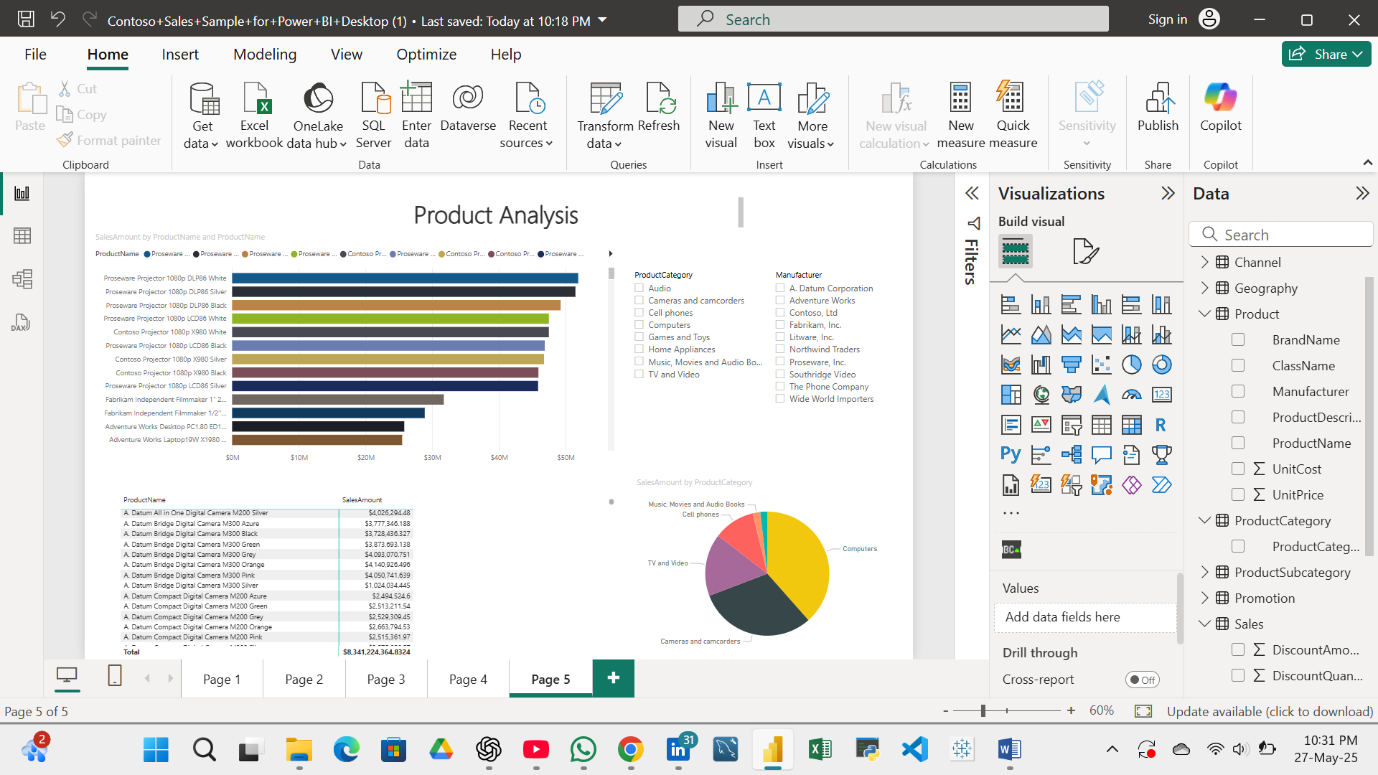
1.Create dashboard on Contoso sale file which highlight Product analysis, Sales Analysis.

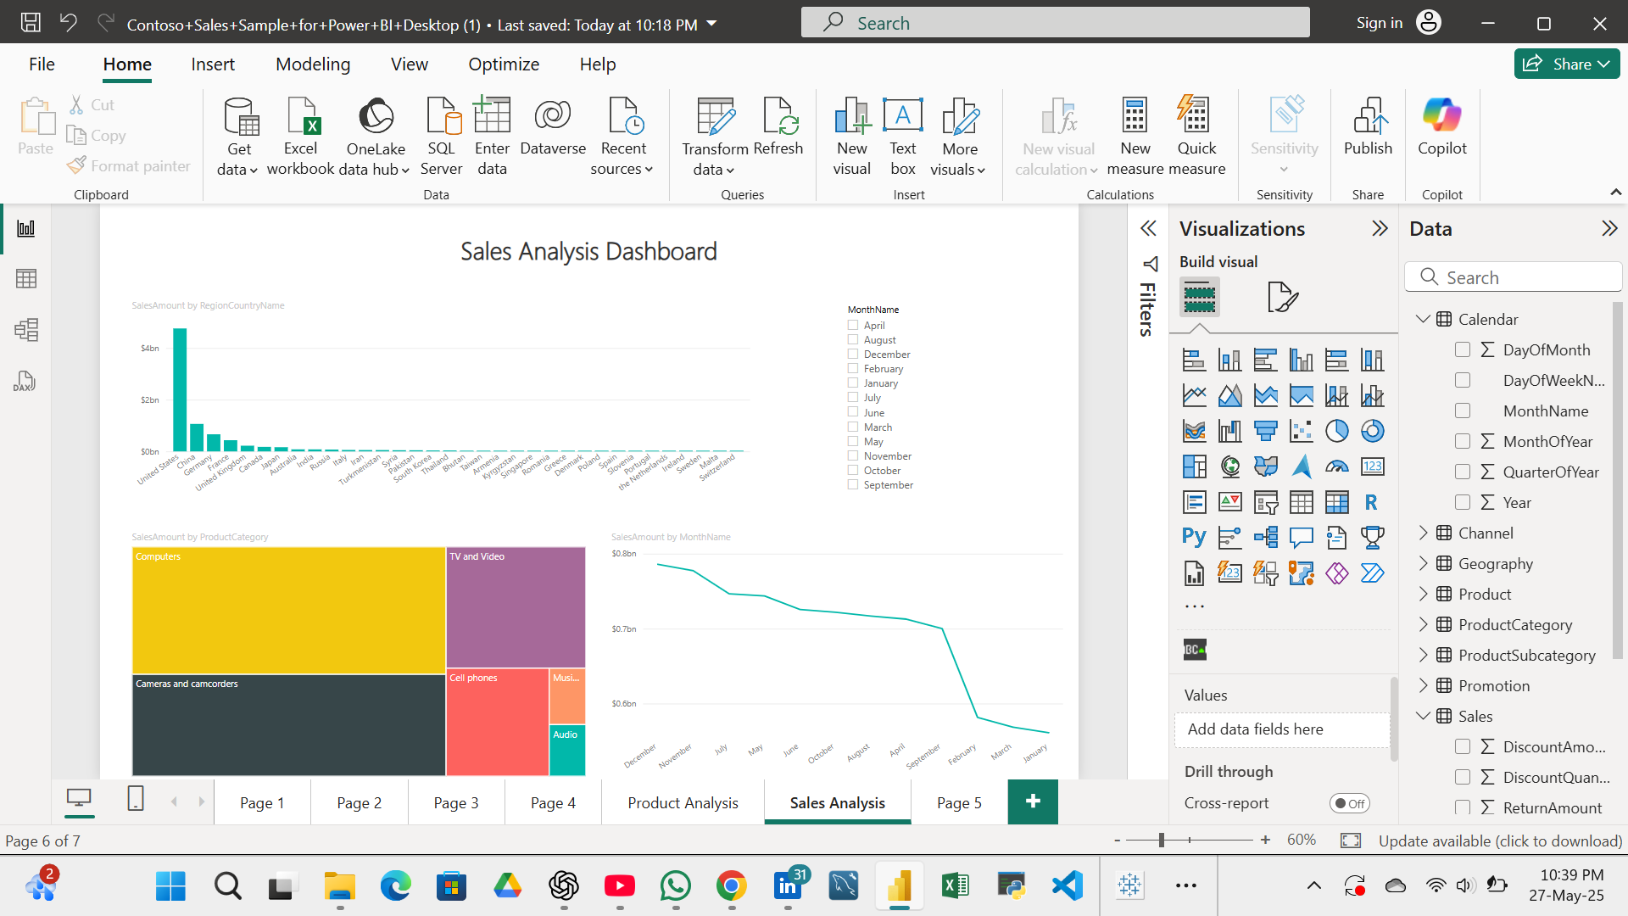

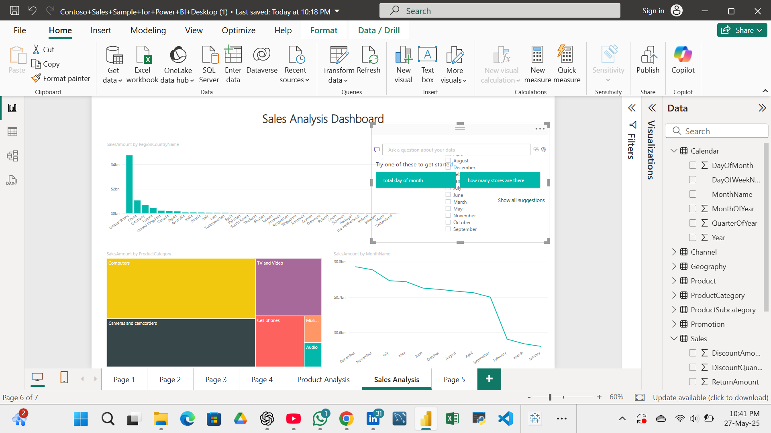
2.Apply Power BI Q and A on created dashboard.

3.Apply Smart narrative on specific chart and on complete dashboard.
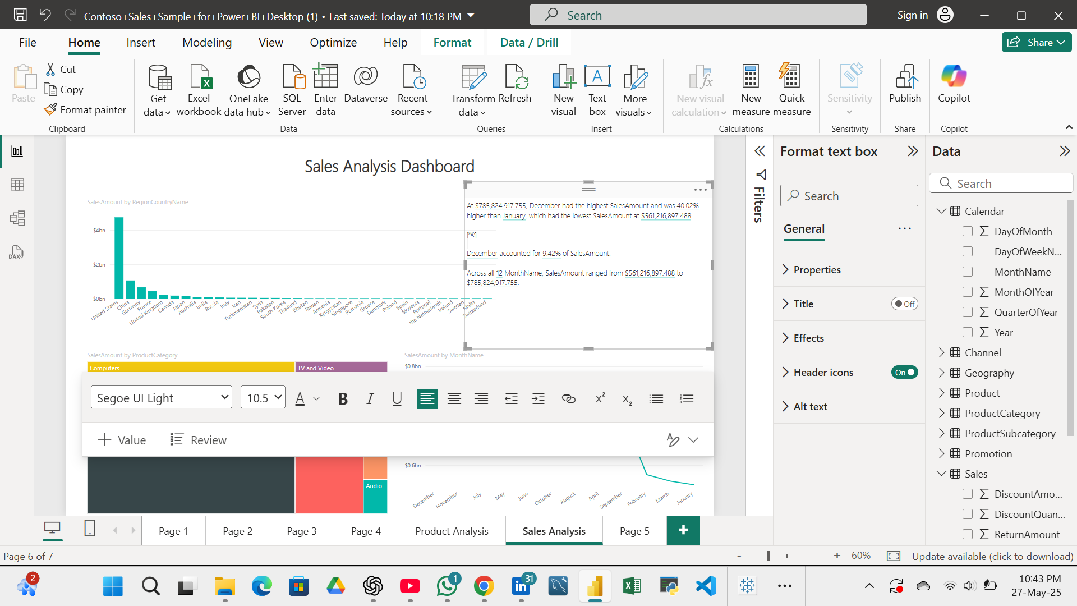

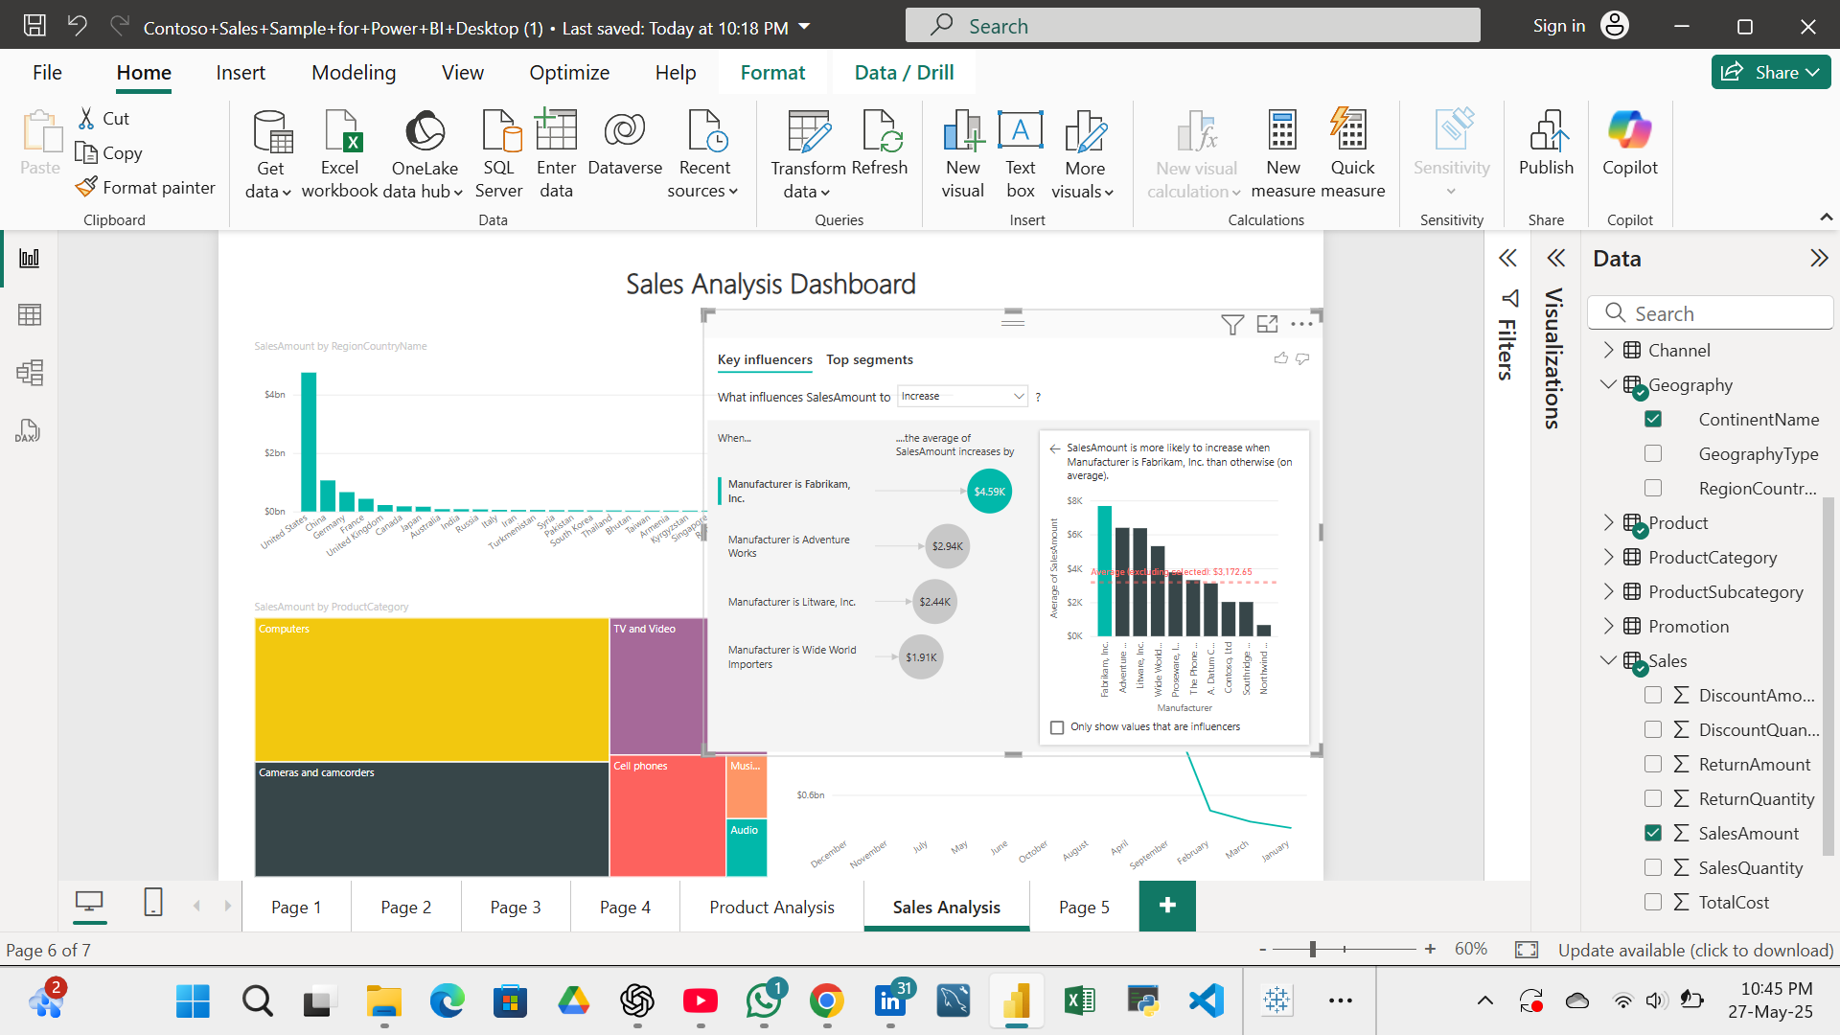
4.Apply Key influencer for analysing SalesAmount which explain by manufacturer, product name and Continent name.

